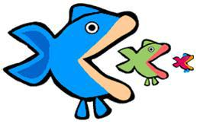
Name: ________________________________
Date: _______________ Class: _________

Food Chains and Food Webs
FOOD CHAINS

- A food chain shows the flow of _________ from one organisms to another. The arrows in a food chain show ___________________________________.

- The original source of energy in food chains comes from _________________. Producers can use this energy to produce food for themselves from __________________ things through a process called _________________. Some examples of producers are: _________________ and ___________________.

- Consumers: organisms that cannot produce their own food. There are three types of consumers.

  - Carnivore: ______________________________________________________

  - Herbivore: ______________________________________________________

  - Omnivore: ______________________________________________________

- Consumers must obtain food by eating other organisms. There are different types of consumers based on where they are placed in a food chain.

  - The first consumer in a food chain is called a primary consumer and it eats the producers.

  - The second consumer in a food chain is called a secondary consumer and it eats the ___________________________________

  - The third consumer in a food chain is called a tertiary consumer and it eats the ______________________________________

  - The fourth consumer in a food chain is called a quaternary consumer and it eats the _________________________________

- All organisms will eventually die at the end of their life cycle. This would pile up in an ecosystem if it were not for organisms called _________________ which __________________________________.

- Nutrients created by decomposers go into the soil and get absorbed by _________________, so the cycle in a food chain can restart.
- Label this food chain with the trophic level of each organism and its position in the food chain (producer, type of consumer)

Trophic Level | 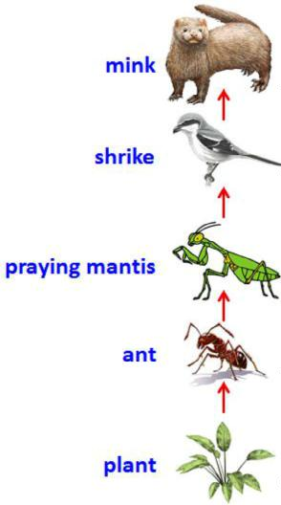 | Position in Food Chain
_______ |  | __________________________________
_______ |  | __________________________________
_______ |  | __________________________________
_______ |  | __________________________________
_______ |  | __________________________________

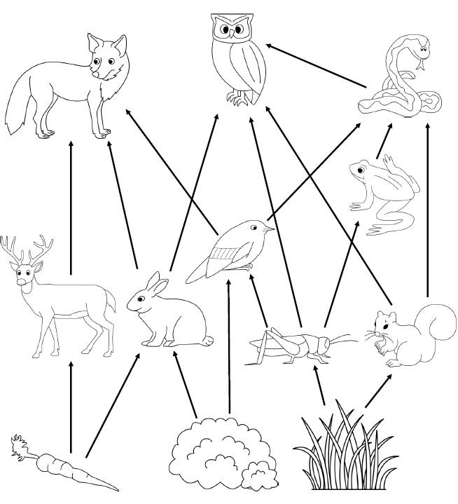
FOOD WEBS

- A food ________ is a group of interlinked food _______.

- Draw two food chains from the food web to the right.

- If the deer population DECREASES, what would happen to:

    - Carrots? ______________________________

    - Fox? _________________________________

    - Rabbits? _______________________________

  - If the owl population DECREASES, what would happen to:

    - Rabbits? __________________________________

    - Fox? ______________________________________

    - Deer? ______________________________________

  - If the snake population INCREASES, what would happen to:

    - Frogs? ______________________________________

    - Squirrels? ___________________________________

    - Owls? ______________________________________

